(Date to be mentioned –the date on which the experiment was carried out in the lab)
Experiment 2
Configure network using cisco packet tracer.
Aim
To Configure network using cisco packet tracer.
Introduction
Packet Tracer is a protocol simulator developed by Dennis Frezzo and his team at Cisco Systems. Packet Tracer (PT) is a powerful and dynamic tool that displays the various protocols used in networking, in either Real Time or Simulation mode. This includes layer 2 protocols such as Ethernet and PPP, layer 3 protocols such as IP, ICMP, and ARP, and layer 4 protocols such as TCP and UDP. Routing protocols can also be traced.
Procedure
Step 1: Start Packet Tracer
(to be described in detail by students in own words)

Step 2: Choosing Devices and Connections
(to be described in detail by students in own words)

Step 3: Building the Topology – Adding Hosts
(to be described in detail by students in own words)

Step 4: Building the Topology – Connecting the Hosts to Hubs and Switches
(to be described in detail by students in own words)

Step 5: Configuring IP Addresses and Subnet Masks on the Hosts
(to be described in detail by students in own words)

Step 6: Connecting Hub0 to Switch0
(to be described in detail by students in own words)

Step 7: Verifying Connectivity in Realtime Mode
(to be described in detail by students in own words)

Step 8: Verifying Connectivity in Simulation Mode
(to be described in detail by students in own words)

Step 9: Saving the Topology
(to be described in detail by students in own words)

(diagram to be represented in the left side)
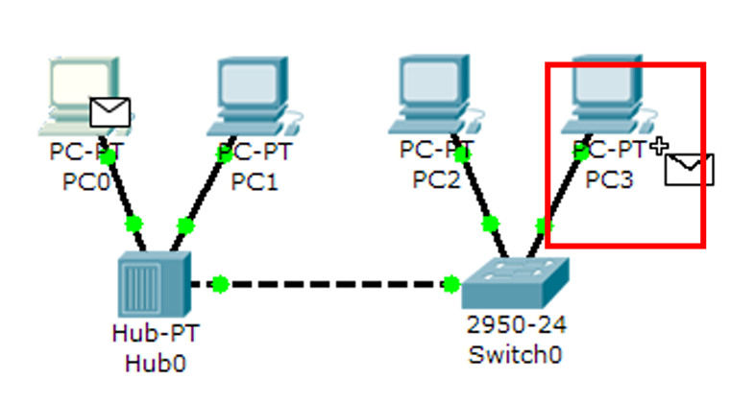
(Fig- network configuration)

Results and discussion
Successfully Configured the network with the help of packet tracer

